**Advertisement Sale prediction from an existing customer**

1. **Finding the problem** – Developing the machine learning algorithm to predict weather this new customer will buy this product or not.
2. **Collecting Dataset** –based on which parameter the person will buy this product or not

E.g.: based on age, salary of existing customer status (Purchased or Not purchased)

Here Input parameters are age, salary.

Output: Purchase status.

1. **Load & Summarize Dataset –** Load dataset from the directory & summarize the details such as no. of rows and columns & content.

**E.g. : Pandas – Load CSV format Dataset**

Dataset = pandas.read_csv(“dataset.csv”)

* **No. of Rows& columns**

dataset.shape

* **Display 1st 5 rows of dataset.**

dataset.head(5)

1. **Segregating Dataset into X & Y**

**Iloc:** It helps us select a value that belongs to a particular row or column.

**Syntax:** dataset.iloc[:,start_col;end_col]

**X= dataset.**iloc[:,:-1].values

**Y = dataset.**iloc[:,-1].values

1. **Splitting Dataset to Train and Test**

Useful for validation

**train_test_split(X,Y,test_size=0.25,random_state=0)**

1. **Feature Scaling:**

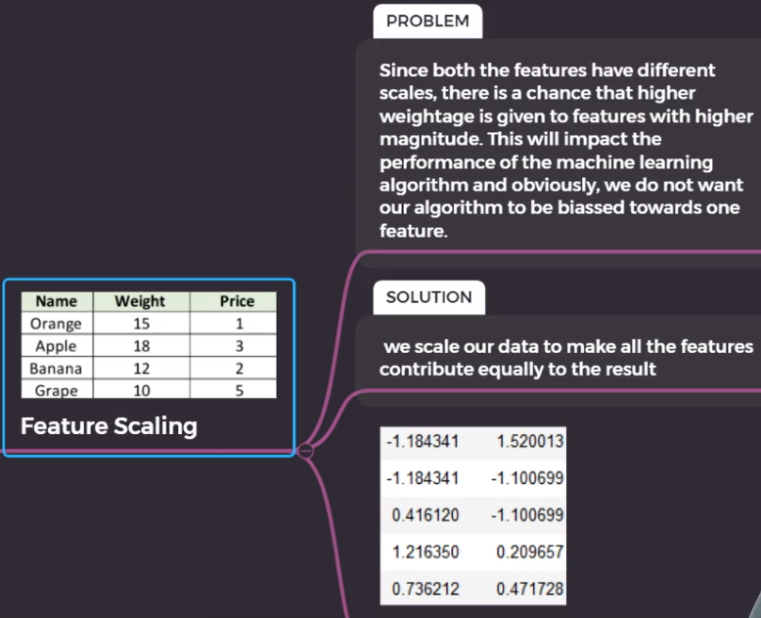

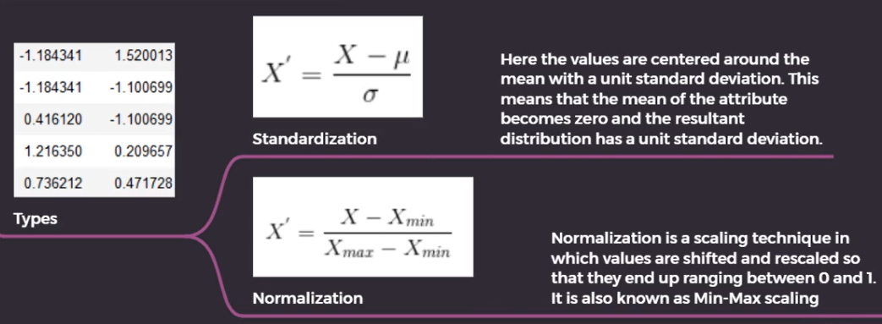

1. **Algorithm**

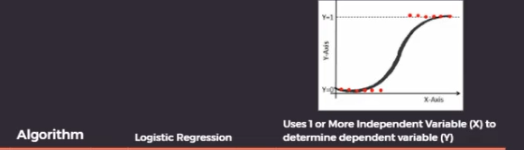

1. **Training -** Training our Model for Pre-processed dataset.

**Eg:** model.fit(X_train,y_train)

1. **Validation:**

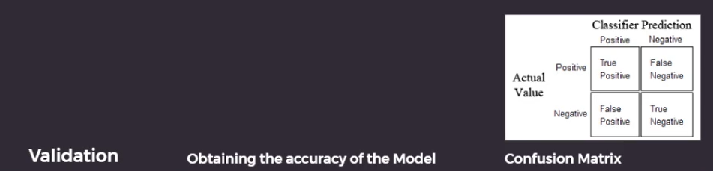

1. **Prediction :**

